Project Plan

SEG2012GP9

|  |  |
| --- | --- |
| Seabrook, Edward J F | [ejfs1g10@ecs.soton.ac.uk](mailto:ejfs1g10@ecs.soton.ac.uk) |
| Elliott, Kristian | [ke1g10@ ecs.soton.ac.uk](mailto:ke1g10@soton.ac.uk) |
| Yu, Brian | [by2g10@ ecs.soton.ac.uk](mailto:by2g10@soton.ac.uk) |
| Mariani Elola, Oscar N | [onme1g10@ ecs.soton.ac.uk](mailto:onme1g10@soton.ac.uk) |
| Chan, Yun Chak | [ycc1g11@ ecs.soton.ac.uk](mailto:ycc1g11@soton.ac.uk) |

# Document Control

|  |  |  |
| --- | --- | --- |
| **Version** | **Author** | **Changes** |
| 1 | by2g10 | Initial document |
| 2 | ejfs1g10 | Adjusted style to match ‘House Style’ |
| 3 | ejfs1g10 | Added preliminary Gantt chart |
| 4 | ejfs1g10 | Added section numbers |
| 5 | ejfs1g10 | Aligned names on front page |
| 6 | ejfs1g10 | Added headers and footers |

# 0.2 Table of Contents

0.1 Document Control 2

0.2 Table of Contents 3

1.1 Gantt Chart 4

1.2 Work Breakdown 5

2.1 Risk Analysis 6

3.1 Budget 7

4.1 Project management 8

# 1.1 Gantt Chart

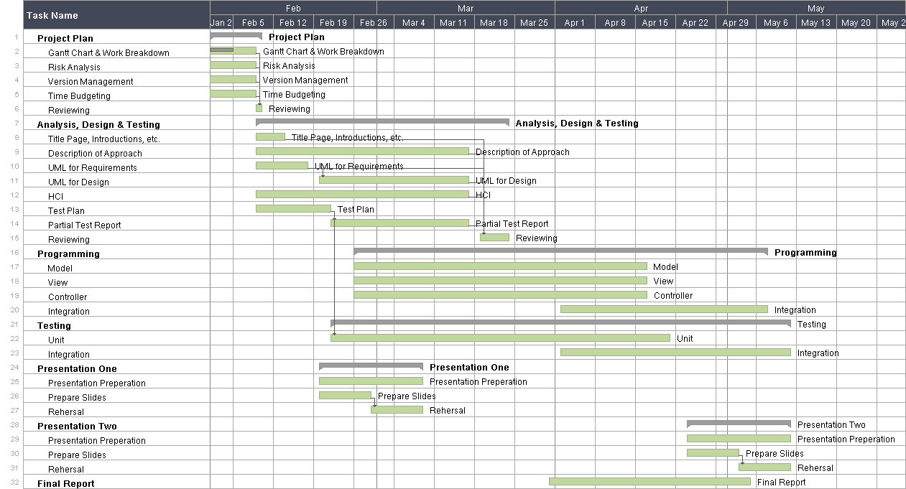

# 1.2 Work Breakdown

# 2.1 Risk Analysis

Something

# 3.1 Budget

Something

# 4.1 Project management

something